**Name- Satyam Hans(J521)**

**Topic- Banking System**

**Tasks 1**: **Database Design**:

create database Bank;

CREATE TABLE Customers (

customer_id INT AUTO_INCREMENT PRIMARY KEY,

first_name VARCHAR(100) NOT NULL,

last_name VARCHAR(100) NOT NULL,

DOB DATE,

email VARCHAR(255) UNIQUE,

phone_number VARCHAR(15),

address VARCHAR(255)

);

create table Accounts (

account_id int auto_increment primary key,

customer_id int,

account_type enum('savings','current','zero_balance'),

balance decimal(10,2) not null,

foreign key(customer_id) references Customers(customer_id) on delete cascade on update cascade

);

create table Transactions (

transaction_id int auto_increment primary key,

account_id int,

transaction_type enum('deposit', 'withdrawal', 'transfer'),

amount decimal(10,2) not null,

transaction_date date not null,

foreign key Accounts(account_id) references Accounts(account_id) on delete cascade on update cascade

);

4. Create an ERD (Entity Relationship Diagram) for the database.

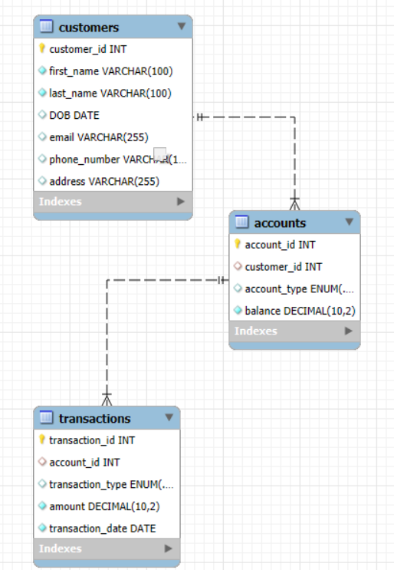

**Task 2**  
1) 1. Insert at least 10 sample records into each of the following tables. • Customers • Accounts • Transactions  
INSERT INTO Customers (first_name, last_name, DOB, email, phone_number, address)

VALUES

('John', 'Doe', '1985-03-15', 'john.doe@example.com', '1234567890', '123 Elm St'),

('Jane', 'Smith', '1990-06-25', 'jane.smith@example.com', '0987654321', '456 Oak St'),

('Sam', 'Johnson', '1975-11-05', 'sam.johnson@example.com', '9876543210', '789 Pine St'),

('Sara', 'Williams', '1983-02-10', 'sara.williams@example.com', '3216549870', '321 Maple St'),

('David', 'Brown', '1995-09-20', 'david.brown@example.com', '6541239876', '654 Cedar St'),

('Emily', 'Davis', '1998-12-12', 'emily.davis@example.com', '7412589630', '963 Birch St'),

('Michael', 'Miller', '1987-08-01', 'michael.miller@example.com', '8523697412', '852 Ash St'),

('Laura', 'Wilson', '1993-07-07', 'laura.wilson@example.com', '9638527410', '741 Beech St'),

('Tom', 'Taylor', '1980-01-25', 'tom.taylor@example.com', '1597534862', '258 Willow St'),

('Anna', 'Anderson', '1992-03-14', 'anna.anderson@example.com', '2589631470', '147 Elmwood St');

INSERT INTO Accounts (customer_id, account_type, balance)

VALUES

(1, 'savings', 15000.00),

(2, 'current', 25000.00),

(3, 'savings', 32000.00),

(4, 'zero_balance', 0.00),

(5, 'current', 50000.00),

(6, 'savings', 22000.50),

(7, 'current', 30000.00),

(8, 'savings', 12000.75),

(9, 'zero_balance', 0.00),

(10, 'current', 42000.00);

INSERT INTO Transactions (account_id, transaction_type, amount, transaction_date)

VALUES

(1, 'deposit', 5000.00, '2024-09-01'),

(1, 'withdrawal', 2000.00, '2024-09-05'),

(2, 'deposit', 10000.00, '2024-09-02'),

(3, 'withdrawal', 3000.00, '2024-09-03'),

(4, 'deposit', 4000.00, '2024-09-04'),

(5, 'withdrawal', 15000.00, '2024-09-05'),

(6, 'deposit', 2500.50, '2024-09-06'),

(7, 'deposit', 5000.00, '2024-09-07'),

(8, 'withdrawal', 1200.75, '2024-09-08'),

(9, 'deposit', 2000.00, '2024-09-09'),

(10, 'withdrawal', 4000.00, '2024-09-10');

2) Write SQL queries for the following tasks:

1. **Write a SQL query to retrieve the name, account type and email of all customers.**

select concat (c.first_name, ' ',c.last_name) as customer_name, a.account_type, c.email

from customers c join accounts a

on c.customer_id=a.customer_id;

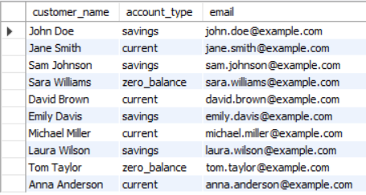

1. **. Write a SQL query to list all transaction corresponding customer.**

select concat(c.first_name, ' ', c.last_name) as customer_name,

t.transaction_id,

t.transaction_type,

t.amount,

t.transaction_date

from customers c join accounts a

on c.customer_id=a.customer_id

join transactions t

on a.account_id=t.account_id;

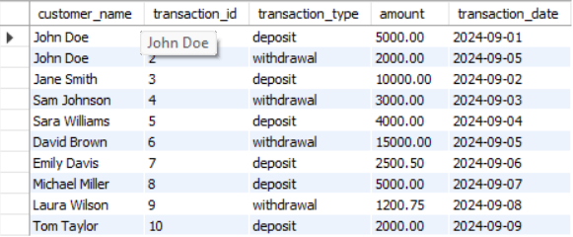

1. **Write a SQL query to increase the balance of a specific account by a certain amount.**

update accounts

set balance=balance + 10000

where account_id=6;

1. **Write a SQL query to Combine first and last names of customers as a full_name.**

select concat(first_name,' ',last_name) as full_name from customers;

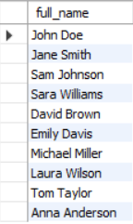

1. **Write a SQL query to remove accounts with a balance of zero where the account type is savings.**

DELETE FROM Accounts

WHERE balance = 0

AND account_type = 'savings';

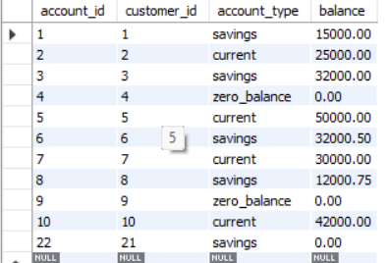

1. **Write a SQL query to Find customers living in a specific city.**

SELECT *

FROM Customers

WHERE address LIKE '%Faridabad%';



1. **Write a SQL query to Get the account balance for a specific account.**

select balance from accounts

where customer_id=3;



1. **Write a SQL query to List all current accounts with a balance greater than $1,000.**

select * from accounts

where account_type='current' and balance > '10000';

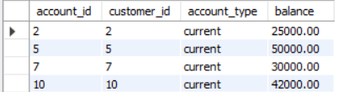

1. **Write a SQL query to Retrieve all transactions for a specific account.**

select * from transactions

where account_id=1;

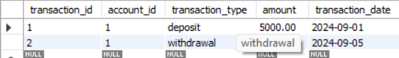

**10. Write a SQL query to Calculate the interest accrued on savings accounts based on a given interest rate.**

SELECT account_id, balance,

(balance * 7 / 100) AS interest_accrued

FROM Accounts

WHERE account_type = 'savings';

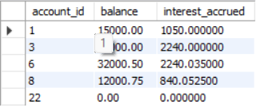

**11. Write a SQL query to Identify accounts where the balance is less than a specified overdraft limit.**

SELECT account_id, customer_id, account_type, balance

FROM Accounts

WHERE balance < 15000;

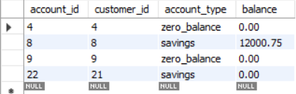

**12. Write a SQL query to Find customers not living in a specific city**

SELECT *

FROM Customers

WHERE address NOT LIKE '%Faridabad%';

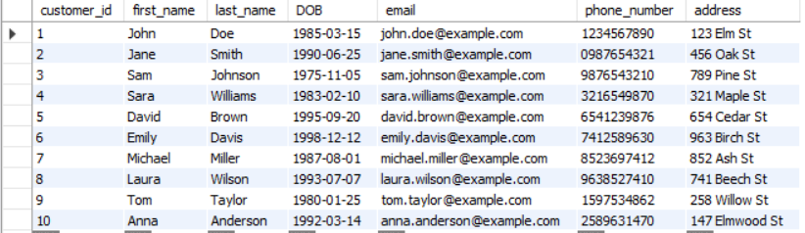

**Tasks 3:** **Aggregate functions, Having, Order By, GroupBy and Joins:**

**1. Write a SQL query to Find the average account balance for all customers.**

SELECT AVG(balance) AS average_balance

FROM Accounts;



**2. Write a SQL query to Retrieve the top 10 highest account balances.**

SELECT *

FROM Accounts

ORDER BY balance DESC

LIMIT 10;

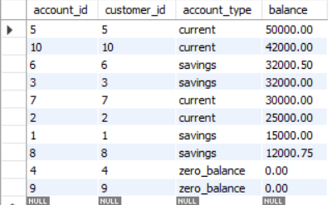

**3. Write a SQL query to Calculate Total Deposits for All Customers in specific date.**

SELECT SUM(amount) AS total_deposits

FROM Transactions

WHERE transaction_type = 'deposit'

AND transaction_date = '2024-09-01';



**4. Write a SQL query to Find the Oldest and Newest Customers.**

SELECT first_name, last_name, DOB —--------(oldest)

FROM Customers

ORDER BY DOB ASC

LIMIT 1;



SELECT first_name, last_name, DOB—---------(newest)

FROM Customers

ORDER BY DOB DESC

LIMIT 1;



**5. Write a SQL query to Retrieve transaction details along with the account type**.

SELECT t.transaction_id, t.amount, t.transaction_type, t.transaction_date, a.account_type

FROM Transactions t

JOIN Accounts a ON t.account_id = a.account_id;

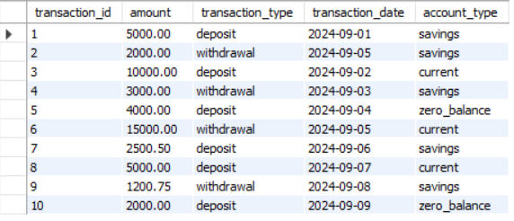

**6. Write a SQL query to Get a list of customers along with their account details.**

SELECT c.first_name, c.last_name, a.account_id, a.account_type, a.balance

FROM Customers c

JOIN Accounts a ON c.customer_id = a.customer_id;

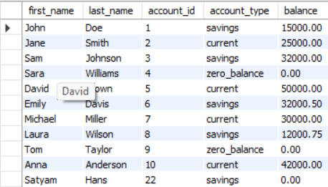

7. Write a SQL query to Retrieve transaction details along with customer information for a specific account.

SELECT t.*, c.first_name, c.last_name, c.email

FROM Transactions t

JOIN Accounts a ON t.account_id = a.account_id

JOIN Customers c ON a.customer_id = c.customer_id

WHERE t.account_id = 5;



8. Write a SQL query to Identify customers who have more than one account.

SELECT customer_id, COUNT(account_id) AS account_count

FROM Accounts

GROUP BY customer_id

HAVING COUNT(account_id) > 1;

9. Write a SQL query to Calculate the difference in transaction amounts between deposits and withdrawals.

SELECT account_id,

SUM(CASE WHEN transaction_type = 'deposit' THEN amount ELSE 0 END) -

SUM(CASE WHEN transaction_type = 'withdrawal' THEN amount ELSE 0 END) AS balance_difference

FROM Transactions

GROUP BY account_id;

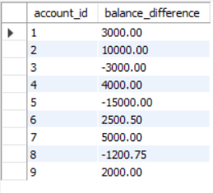

10. Write a SQL query to Calculate the average daily balance for each account over a specified period.

SELECT account_id, AVG(balance) AS average_daily_balance

FROM Transactions

WHERE transaction_date BETWEEN 'YYYY-MM-DD' AND 'YYYY-MM-DD'

GROUP BY account_id;

11. Calculate the total balance for each account type.

SELECT account_type, SUM(balance) AS total_balance

FROM Accounts

GROUP BY account_type;

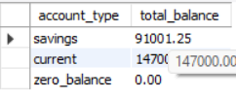

12. Identify accounts with the highest number of transactions order by descending order.

SELECT account_id, COUNT(transaction_id) AS transaction_count

FROM Transactions

GROUP BY account_id

ORDER BY transaction_count DESC;

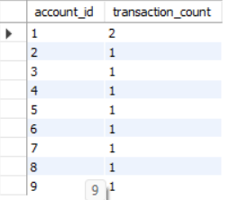

13. List customers with high aggregate account balances, along with their account types.

SELECT c.first_name, c.last_name, a.account_type, SUM(a.balance) AS total_balance

FROM Customers c

JOIN Accounts a ON c.customer_id = a.customer_id

GROUP BY c.customer_id, a.account_type

HAVING SUM(a.balance) > 20000;

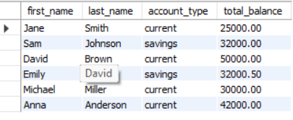

14. Identify and list duplicate transactions based on transaction amount, date, and account.

SELECT account_id, transaction_date, amount, COUNT(*) AS duplicate_count

FROM Transactions

GROUP BY account_id, transaction_date, amount

HAVING COUNT(*) > 1;

**Tasks 4: Subquery and its type:**

1. Retrieve the customer(s) with the highest account balance.

SELECT first_name, last_name, balance

FROM Customers c

JOIN Accounts a ON c.customer_id = a.customer_id

WHERE balance = (SELECT MAX(balance) FROM Accounts);



2. Calculate the average account balance for customers who have more than one account.

SELECT customer_id, AVG(balance) AS average_balance

FROM Accounts

GROUP BY customer_id

HAVING COUNT(account_id) > 1;



3. Retrieve accounts with transactions whose amounts exceed the average transaction amount.

FROM Transactions t

WHERE amount > (SELECT AVG(amount) FROM Transactions);

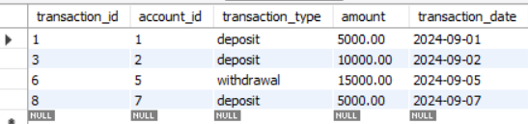

4. Identify customers who have no recorded transactions.

SELECT customer_id, first_name, last_name

FROM Customers

WHERE customer_id NOT IN (

SELECT DISTINCT customer_id

FROM Accounts

JOIN Transactions ON Accounts.account_id = Transactions.account_id

);

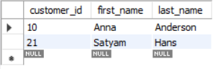

5. Calculate the total balance of accounts with no recorded transactions.

SELECT SUM(balance) AS total_balance

FROM Accounts

WHERE account_id NOT IN (SELECT DISTINCT account_id FROM Transactions);



6. Retrieve transactions for accounts with the lowest balance.

SELECT transaction_id, account_id, transaction_type, amount

FROM Transactions

WHERE account_id = (SELECT account_id FROM Accounts ORDER BY balance ASC LIMIT 1);

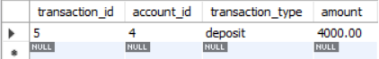

7. Identify customers who have accounts of multiple types.

SELECT customer_id, first_name, last_name

FROM Customers

WHERE customer_id IN (

SELECT customer_id

FROM Accounts

GROUP BY customer_id

HAVING COUNT(DISTINCT account_type) > 1

);

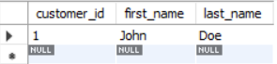

8. Calculate the percentage of each account type out of the total number of accounts.

SELECT account_type,

(COUNT(*) * 100.0) / (SELECT COUNT(*) FROM Accounts) AS percentage

FROM Accounts

GROUP BY account_type;

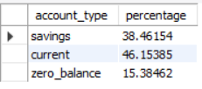

9. Retrieve all transactions for a customer with a given customer_id.

SELECT *

FROM Transactions

JOIN Accounts ON Transactions.account_id = Accounts.account_id

WHERE Accounts.customer_id = 1;



10. Calculate the total balance for each account type, including a subquery within the SELECT clause.

SELECT account_type,

(SELECT SUM(balance)

FROM Accounts

WHERE account_type = a.account_type) AS total_balance

FROM Accounts a

GROUP BY account_type;

